A Project Report on
MACHINE LEARNING FOR EARLY BRAIN STROKE DETECTION
A Dissertation submitted to JNTU Hyderabad in partial fulfillment of the academic requirements for the award of the degree.

Bachelor of Technology
In
Artificial intelligence and Machine Learning

Submitted by

E.Maniteja (21H51A7310)

A.Manideep (21H51A7336)

G.Nagendhra Prasad (21H51A7350)

Under the esteemed guidance of
Mrs.P.R.Prathyusha



Department of AIML

CMR COLLEGE OF ENGINEERING& TECHNOLOGY

(UGC Autonomous)
*Approved by AICTE *Affiliated to JNTUH *NAAC Accredited with A⁺ Grade
KANDLAKOYA, MEDCHAL ROAD, HYDERABAD - 501401.
2024- 2025

CMR COLLEGE OF ENGINEERING & TECHNOLOGY
KANDLAKOYA, MEDCHAL ROAD, HYDERABAD –501401

DEPARTMENT OF AIML



CERTIFICATE
This is to certify that the report entitled “DETECTION OF STROKE DISEASE” is
bonafide work done by E. MAITEJA (21H517310), A. MANIDEEP (21H51A7336), G.NAGENDRAPRASAD(21H51A7350), of III B. TECH I Semester in partial fulfillment of the requirements for the award of the degree of Bachelor of Technology, submitted to Center for Engineering Education Research, CMR College of Engineering & Technology, Hyderabad during the Academic Year of 2024-25.

Mrs.P.R.Prathyusha Dr.S.Kirubakaran
Asst Professor Professor and HOD
Dept.of.AIML Dept.of.AIML

ACKNOWLEDGEMENT
With great pleasure I want to take this opportunity to express my heartfelt gratitude to all the people who helped in making this project work a grand success.
I am grateful to Mrs.Pr.Prathyusha, Professor, Dept of Computer Science and Engineering-AIML for his valuable suggestions and guidance during the execution of this project work.
I would like to thank Dr. P. Sruthi, Head of the Department of Computer Science and Engineering-AIML, for his moral support throughout the period of my study in CMRCET.
I am highly indebted to Major Dr. V.A. Narayana, Principal CMRCET for giving permission to carry out this project in a successful and fruitful way.
I would like to thank the Teaching & Non- teaching staff of Department of Computer Science and Engineering for their co-operation

We would like to thank the Teaching & Non- teaching staff of Department of Dept Name for their co-operation
We express our sincere thanks to Shri. Ch. Gopal Reddy, Secretary& Correspondent, CMR Group of Institutions, and Shri Ch Abhinav Reddy, CEO, CMR Group of Institutions for their continuous care and support.
Finally, we extend thanks to our parents who stood behind us at different stages of this Project. We sincerely acknowledge and thank all those who gave support directly or indirectly in completion of this project work.

E.MANITEJA (21H51A7310)
A.MANIDEEP (21H51A7336)
G.NAGENDHRA PRASD (21H51A7350)

TABLE OF CONTENTS

CHAPTERS |  | DESCRIPTION | PAGE No
 |  | Abstract | 5
1 |  | Introduction | 7
2 |  | Literature Review | 9
3 |  | System analysis
 | 3.1 | Existing systems | 11
 | 3.2 | limitations | 11
 | 3.3 | Software requirements | 11
 | 3.4 | Sorce code | 12-15
4 | 4 | Proposed solution | 17-20
 |  | Block diagram | 21
5 |  | Conclusion | 25
 | 5.1 | Future scope | 25
6 |  | References | 27

ABSTRACT

A stroke is a medical condition in which poor blood flow to the brain results in cell death. It is now a day a leading cause of death all over the world. Several risk factors believe to be related to the cause of stroke has been found by inspecting the affected individuals. Using these risk factors, a number of works have been carried out for predicting and classifying stroke diseases. Most of the models are based on data mining and machine learning algorithms. In this work, we have used four machine learning algorithms to detect the type of stroke that can possibly occur or occurred form a person’s physical state and medical report data. We have collected a good number of entries from the hospitals and use them to solve our problem. The classification result shows that the result is satisfactory and can be used in real time medical report. We believe that machine learning algorithms can help better understanding of diseases and can be a good healthcare companion. So by considering these situations like Heart strokes, Brain Strokes we came up with a new idea to have a robotic system which helps to solve above problems by using “MACHINE LEARNING FOR BRAIN STROKE DETECTION”.

CHAPTER 1

INTRODUCTION

1.INTRODUCTION

The "Detection of Stroke Disease" is an idea or concept aimed at identifying and diagnosing stroke in individuals. Stroke is a medical condition that occurs when there is poor blood flow to the brain, leading to cell death. A Stroke occurs due to poor blood flow to the brain which results in cell death. Two main types of strokes are ischemic stroke and Hemorrhagic stroke. Ischemic stroke occurs due to lack of blood flow and Hemorrhagic stroke due to bleeding. Another type of stroke is transient ischemic attack. Ischemic stroke has two categories-embolic and thrombotic strokes. An embolic stroke occurs by forming a clot in any part of the body and moves toward the brain and blocks blood flow. A thrombotic stroke caused by a clot that weakens the blood flow in an artery. So, we came up with an idea named “DETECTION OF STROKE DISEASE”.
The concept of "Detection of Stroke Disease" involves developing methods, potentially using data mining and machine learning algorithms, to analyze an individual's physical state and medical reports. By examining relevant risk factors associated with stroke and utilizing these algorithms, the goal is to accurately predict and classify the type of stroke an individual may have experienced or is at risk of experiencing.
The ultimate aim of this idea is to create a reliable and efficient system that can detect and diagnose stroke, thereby enabling timely medical intervention and appropriate treatment. This could potentially improve patient outcomes and assist healthcare professionals in providing effective care for stroke patients.

Objectives
- The objective of this project is to develop an accurate and accessible method for the detection of stroke disease.
- The proposed solution should be efficient, cost-effective, and capable of identifying stroke cases early on, enabling timely medical intervention.
- To give more accurate result of the detection of stroke.
- Develop a machine learning algorithm for the detection of stroke disease

CHAPTER 2

LITERATURE SURVEY

2.LITERATURE SURVEY

Several studies have been conducted to explore the use of data mining and machine learning for stroke detection and diagnosis. One study employed a decision tree algorithm to identify the risk factors associated with stroke. By analyzing patient data such as age, blood pressure, cholesterol levels, and smoking habits, the algorithm could predict the likelihood of stroke development. The results showed that decision tree-based models can assist in assessing stroke risk in individuals
Another study focused on using machine learning algorithms to classify different types of strokes. By employing a support vector machine (SVM) classifier with features extracted from brain imaging data, the researchers achieved a high accuracy in classifying ischemic stroke, hemorrhagic stroke, and transient ischemic attack. This suggests the potential for machine learning algorithms to aid in distinguishing between stroke subtypes, which is crucial for appropriate treatment decisions.
Although the implementation of data mining and machine learning in stroke detection shows promising results, it is essential to address certain challenges. These include the need for large and diverse datasets for training and validation, standardization of data collection and feature extraction methods, and ensuring the interpretability and generalizability of the developed models.

CHAPTER 3

SYSTEM ANALSIS

3.SYSTEM ANALSIS

3.1 Existing System
• Manual Checkups.
• Computerized tomography (CT scan).
• Magnetic resonance imaging (MRI)
• Echocardiogram

3.2 Limitations of existing system
•Incorrect classification results
•Accuracy of classification low

3.3 Software requirments
3.3.1 Font end
HTML:
HTML (Hypertext Markup Language) is the standard markup language used for creating web pages and applications. It provides the structure and formatting for the content displayed on the web. HTML consists of a series of elements, which are represented by tags enclosed in angle brackets.
CSS:
Cascading Style Sheets is a style sheet language used for describing the presentation of a document written in a markup language such as HTML or XML. CSS is a cornerstone technology of the World Wide Web, alongside HTML and JavaScript.
JAVASCRIPT:
JavaScript is the programming language of the Web. JavaScript is easy to learn. This tutorial will teach you JavaScript from basic to advanced.

3.3.2 Back end
PYTHON:
Python is a general-purpose language, meaning it can be used to create a variety of different programs and isn't specialized for any specific problems.
SQL LITE:
SQLite is used to develop embedded software for devices like televisions, cell phones, cameras, etc. It can manage low to medium-traffic HTTP requests. SQLite can change files into smaller size archives with lesser metadata. SQLite is used as a temporary dataset to get processed with some data within an application

Source code
import os import sys if _name_ == "_main_":
os. environ.setdefault("DJANGO_SETTINGS_MODULE", "heart_disease.settings") try:
from django.core.management import execute_from_command_line except ImportError as exc: raise ImportError(
"Couldn't import Django. Are you sure it's installed and "
"available on your PYTHONPATH environment variable? Did you " "forget to activate a virtual environment?"
)
from exc execute_from_command_line(sys.argv)
{% load static %}
<!DOCTYPE html>
<html lang="">
<head>
<title>Prediction</title>
<meta charset="utf-8">
<meta name="viewport" content="width=device-width, initial-scale=1.0, maximum-scale=1.0, user-scalable=no">
<link href="{% static 'layout/styles/layout.css' %}" rel="stylesheet" type="text/css" media="all"> </head>
<body id="top" style="background-color:goldenrod;">
<div class="bgded overlay" style="background-image:url('images/demo/backgrounds/01.png');">
<div class="wrapper row0">
<div id="topbar" class="hoc clear">
<div class="fl_left">
</div>
<div class="fl_right">
</div>
</div>
</div>
<div class="wrapper row1">
<header id="header" class="hoc clear">
<div id="logo" class="fl_left">

<h1><a href="#">DETECTION OF BRAIN STROKE DISEASE USING MACHINE
LEARNING</a></h1>
</div>
<nav id="mainav" class="fl_right">
<ul class="clear">
<li><a href="{% url 'dec' %}">PassiveAgrressiveClassifier</a></li>
<li><a href="{% url 'randomf' %}">Decision tree</a></li>
<li><a href="{% url 'nvb' %}">Test the input</a>
<li><a href="{% url 'mnb' %}">Supportvectorclassifier</a></li>
<li><a href="{% url 'graph' %}">AdaBoostClassifier</a></li>

</ul>
</nav>
</header>
</div>
<div id="pageintro" class="hoc clear"style="background-image: url('https://img.freepik.com/freevector/brain-chemistry-concept-illustration_114360-
10136.jpg?w=1060&t=st=1689006685~exp=1689007285~hmac=8edd235eb136dac55e72f9f7080a2 34d22934dcba737a727ba09054f3c415366');background-repeat: no-repeat; background-position:
center;background-size:cover">
<article class="center">
<footer><a class="btn" href="#">BRAIN STROKE DISEASE PREDICTION :<h5>{{predictedvalue}}</h5></a></footer><br>

<footer><a class="btn" href="#">ACCURACY:<h5>{{accuracy}}</h5></a></footer>
</article>
</div>
</div>
<div class="wrapper row2">
<section class="hoc container clear">
<div class="center btmspace-80">
</section>
</div>


<div class="wrapper row5">
<div id="copyright" class="hoc clear">
</div>
</div>
<a id="backtotop" href="#top"><i class="fas fa-chevron-up"></i></a>
<script src="{% static 'layout/scripts/jquery.min.js' %}"></script>

<script src="{% static 'layout/scripts/jquery.backtotop.js' %}"></script>
<script src="{% static 'layout/scripts/jquery.mobilemenu.js' %}"></script>
</body>
</html>

CHAPTER 4
PROPOSED SOLUTION

4.PROPOSED SOLUTION

In this work, we have used four machine algorithms We used a machine learning based diagnosis method for the identification of Brain stroke in this research work. Machine learning predictive models include SVM, DT, and Adabooster,
passive aggressive are used for the identification ofBrain stroke.

4.1 Problem defination

The problem is to develop an effective method for the detection of stroke disease in individuals. Stroke is a serious medical condition that occurs when the blood supply to the brain is interrupted or reduced, leading to damage or death of brain cells. It is a leading cause of death and disability worldwide. Early detection of stroke is crucial for timely medical intervention, as prompt treatment can help minimize brain damage and improve patient outcomes.
However, stroke detection can be challenging due to the varied symptoms and the need for specialized medical expertise. The current diagnostic methods, such as physical examination, medical imaging and clinical assessment, are often time-consuming, costly, and require access to medical facilities.

4.2 Algorithms that we used
- Passive aggressive classifier
- Adabooster classifier
- Support vector classifier
- Decision tree

- Passive aggressive classifier:

The classifier updates its model incrementally, adapting to new data as it arrives. It makes small adjustments to its weight vector based on the classification error of each instance. The Passive Aggressive Classifier is designed for binary classification problems, where the goal is to assign instances to one of two classes based on their features. The Passive Aggressive Classifier has been applied in various domains, including text classification, sentiment analysis, and online prediction tasks. Its ability to handle streaming data and adapt to changing environments makes it suitable for real-time applications


- Adabooster classifier:
AdaBoost is a boosting algorithm that iteratively combines multiple weak learners to create a strong ensemble classifier. Each weak learner is trained on a subset of the data, and their predictions are combined using a weighted voting scheme. AdaBoost aims to minimize the overall classification error by iteratively focusing on the difficult instances. The final ensemble classifier is constructed by assigning higher weights to the more accurate weak learners and lower weights to the weaker ones.

- Suport vector classifier

Support Vector Machine or SVM is one of the most popular Supervised Learning algorithms, which is used for Classification as well as Regression problems. However, primarily, it is used for Classification problems in Machine Learning. The goal of the SVM algorithm is to create the best line or decision boundary that can segregate n-dimensional space into classes so that we can easily put the new data point in the correct category in the future.

4.Decision tree :
It is a tree-structured classifier, where internal nodes represent the features of a dataset, branches represent the decision rules and each leaf node represents the outcome. Usually, mimic human thinking ability while making a decision, so it is easy to understand. The logic behind the decision tree can be easily understood because it shows a tree-like structure.

4.3 Advantages of proposed solutions

•Better performance

•provide accurate prediction result

BLOCK DIAGRAM:

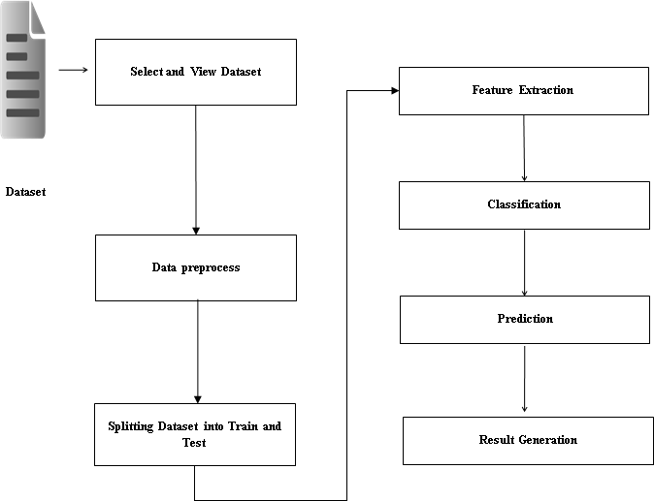

SCREENSHOTS:

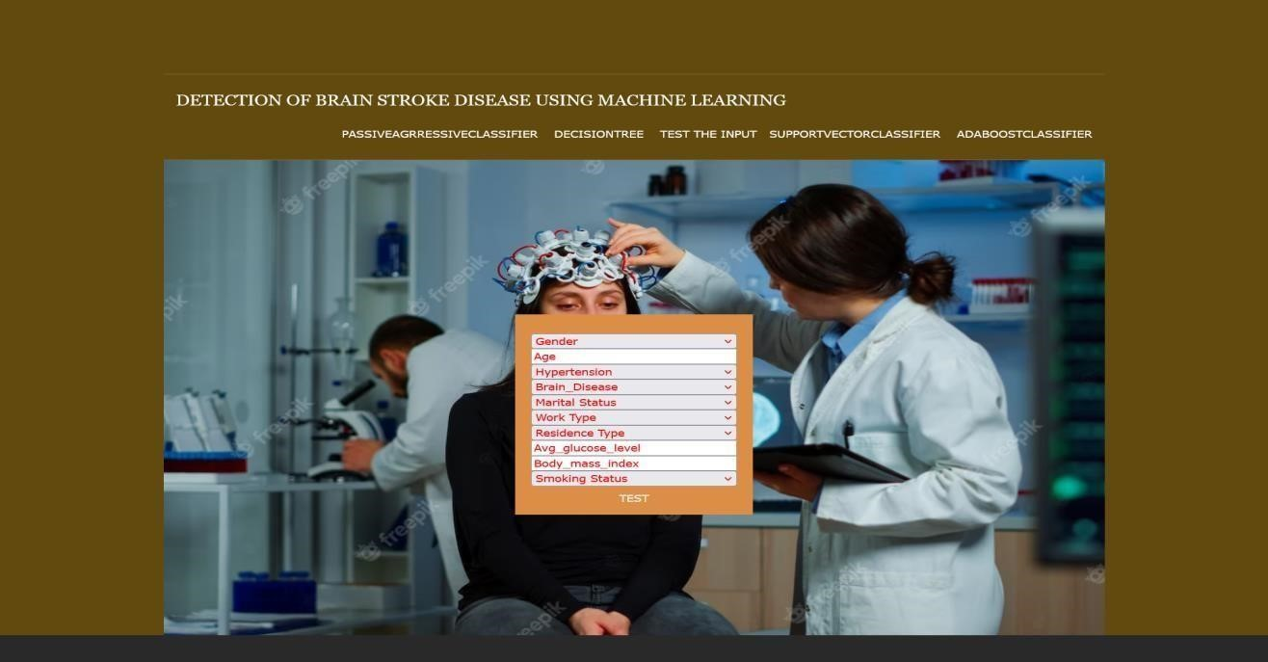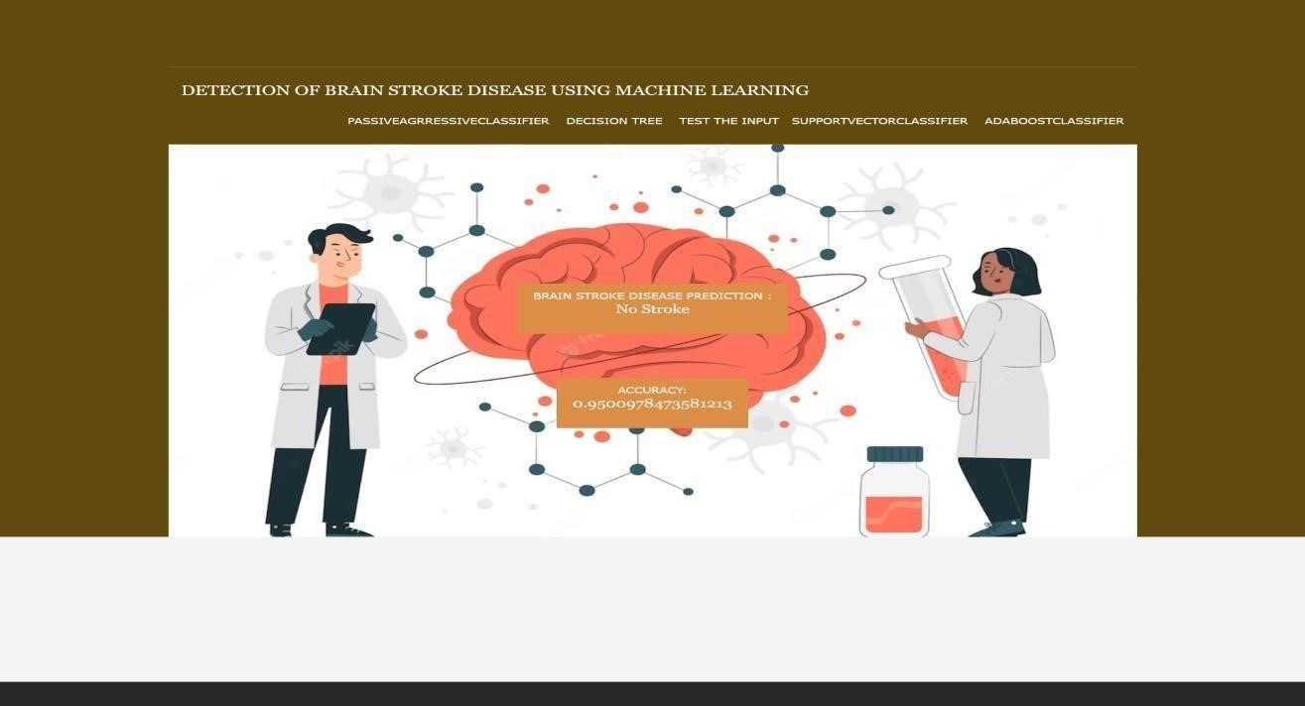

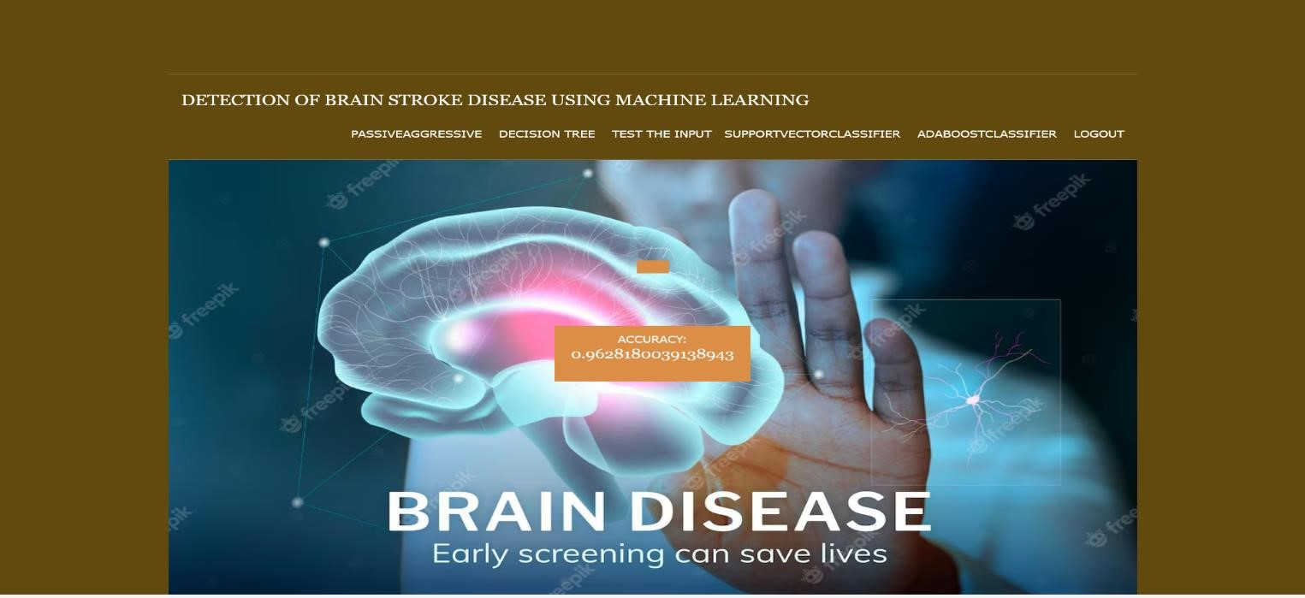

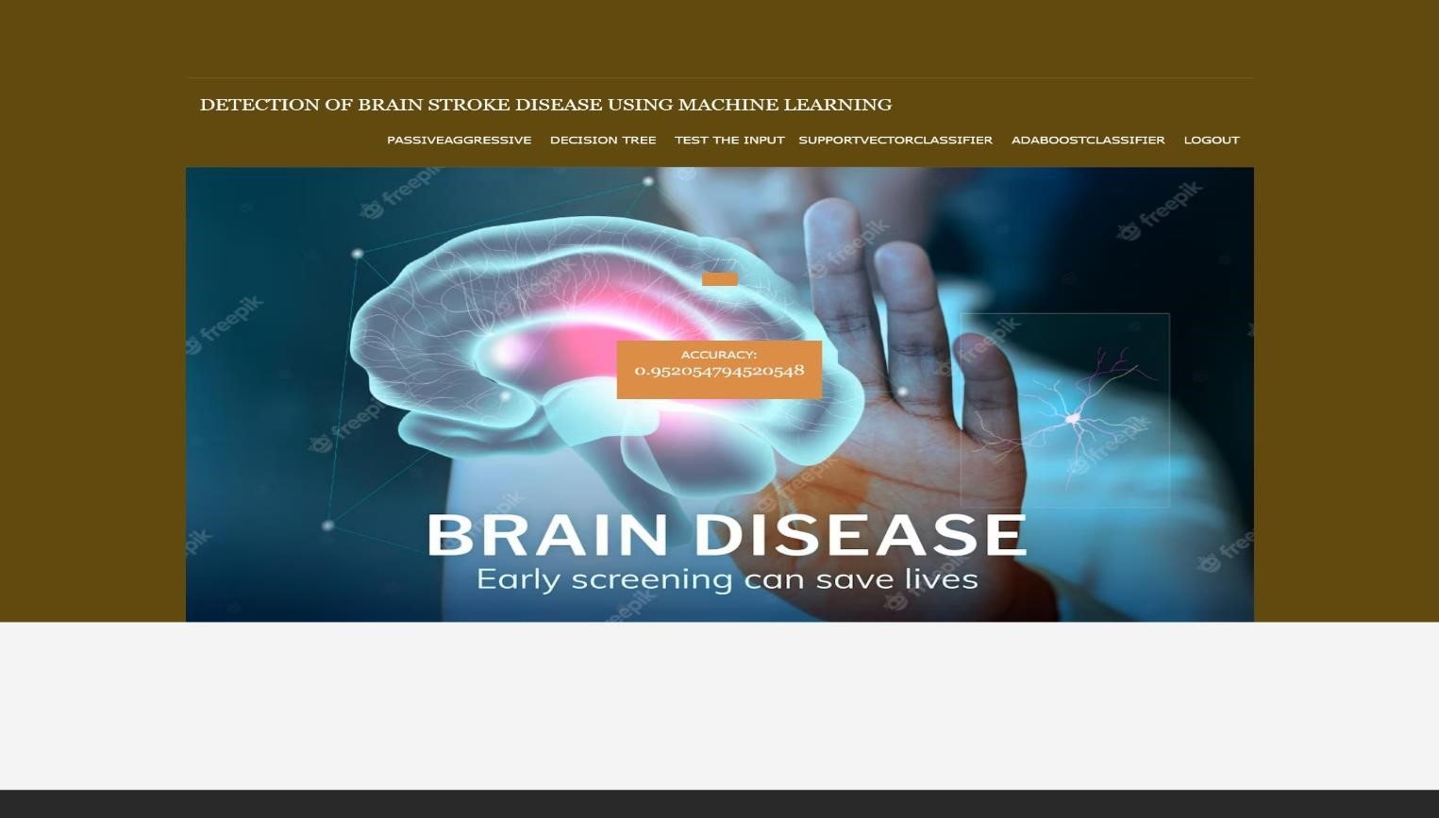

CHAPTER 5
CONCLUSION
AND
FUTURE SCOPE

5. CONCLUSION:

In this work, we have used four machine learning algorithms to detect the type of stroke that can possibly occur or occurred form a person’s physical state and medical report data. We have collected a good number of entries from the hospitals and use them to solve our problem. The classification result shows that the result is satisfactory and can be used in real time medical report. We believe that machine learning algorithms can help better understanding of diseases
And can be a good health care companion. Index Terms—Stroke, Machine Learning, Passive aggressive classifier, Adabooster classifier, Support vector classifier, Decision Tree, Random Forest.

5.1 FUTURE SCOPE
Here are some possible future scope areas for the project:

Enhanced Accuracy: Continuously improving the accuracy of the stroke detection and diagnosis models is a crucial goal. The datasets, refining feature selection techniques, and exploring advanced machine learning algorithms. Real-time Detection: Expanding the project to real-time detection would enable immediate identification of stroke symptoms and timely interventions. Predictive Analytics: Building predictive models to identify individuals who are at higher risk of stroke can be a valuable addition to the project. By analyzing patient data along with other demographic and lifestyle factors, these models can provide personalized risk assessments. Mobile Applications for Education and Awareness: Developing mobile applications is useful to public about stroke symptoms, risk factors, and prevention measures can help raise awareness about stroke. These applications could include interactive educational content, risk assessment tools, and reminders for lifestyle modifications.
These future scope areas highlight the potential for further advancements and applications for the "Detection of Stroke Disease" project. By incorporating new technologies, expanding the scope of detection, and this project can make a significant impact on stroke diagnosis, prevention, and patient outcomes in the future.

REFERENCES

6.REFERENCES

- [A. L. Bui, T. B. Horwich, and G. C. Fonarow, ``Epidemiology and risk problem of heart
failure,''
Nature Rev. Cardiol., vol. 8, no. 1, p. 30, 2011.

- M. Durairaj and N. Ramasamy, ``A comparison of the perceptive approaches for preprocessing the data set for predicting fertility success rate,'' Int. J. Control Theory Appl., vol. 9, no. 27, pp. 255_260, 2016.
- S. Ghwanmeh, A. Mohammad, and A. Al-Ibrahim, ``Innovative artificial neural networks-based decision support system for heart diseases diagnosis,'' J. Intell. Learn. Syst. Appl., vol. 5, no. 3, 2013, Art. no. 35396.

